REQ-8: The system shall allow a card to be moved from one pile in the tableau to one pile in the foundation

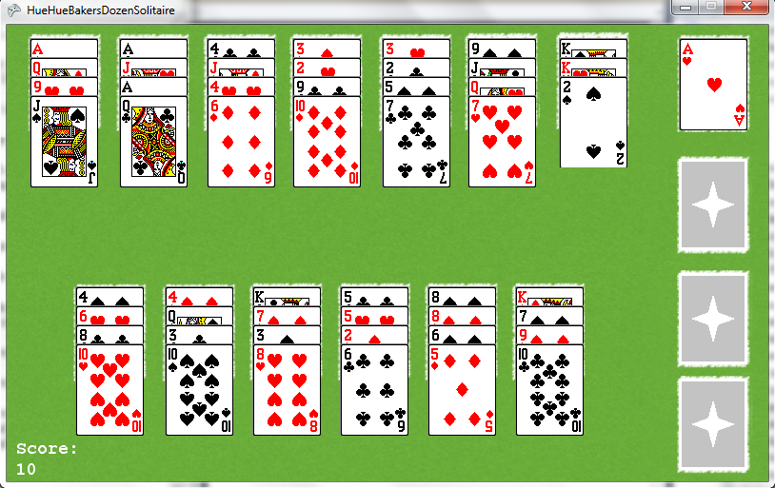

REQ-8.1: The system shall only allow one foundation pile to hold one suit type

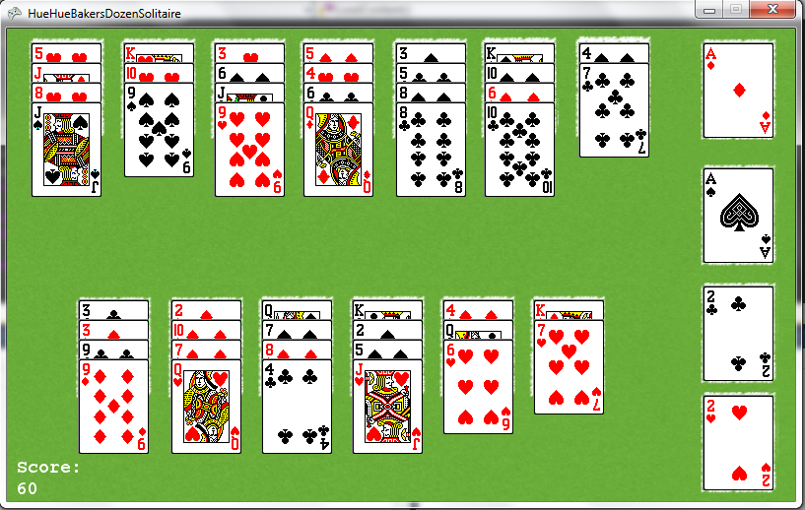

REQ-8.2: The system shall only allow the first card placed in a foundation pile to be an Ace.

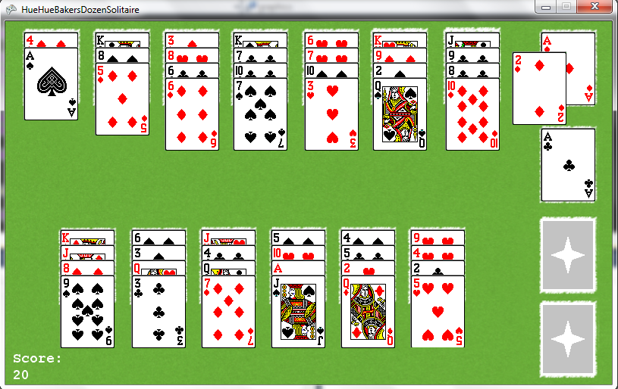

REQ-8.3: The system shall only allow a card placed in the foundation where the current top card is -1 rank of the card being moved.

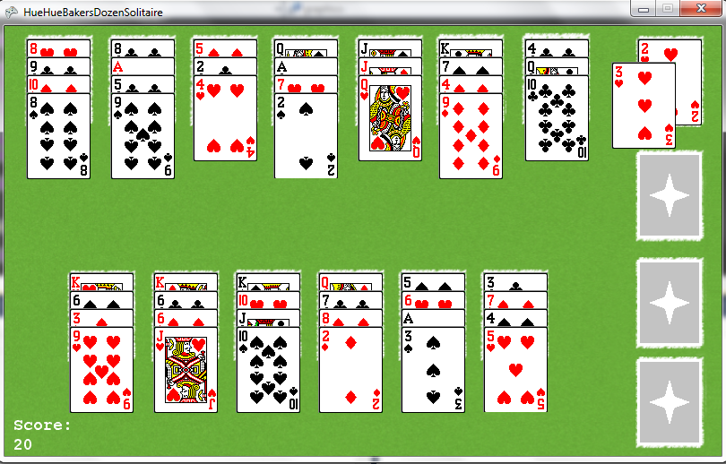

REQ-8.4: The system shall return a card to its originating pile prior to a move if the move is not an acceptable move.

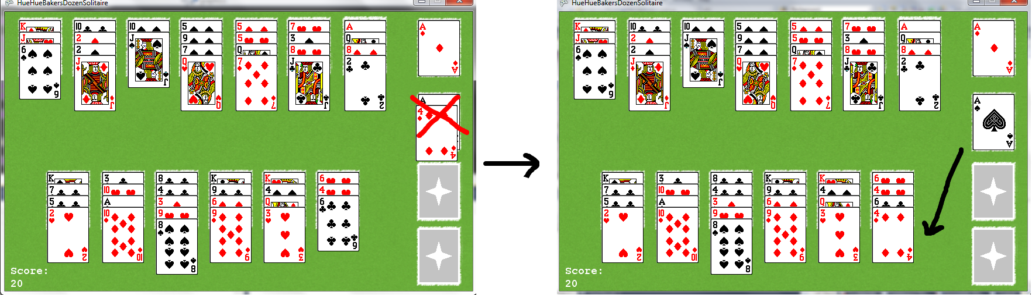

REQ-9: The system shall allow a card to be moved from one pile in the foundation to one pile in the tableau

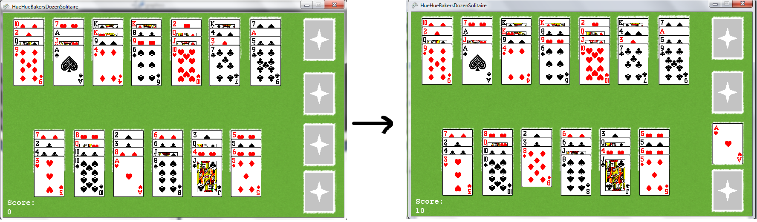

REQ-9.1: The system shall only allow the top card of a foundation pile to be moved.

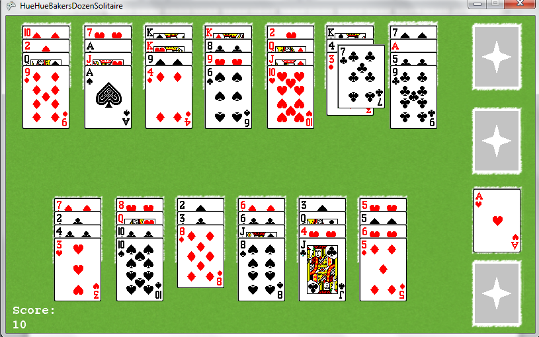

REQ-9.2: The system shall only allow the card to be placed if the current top card of the pile is +1 rank of the card being moved.

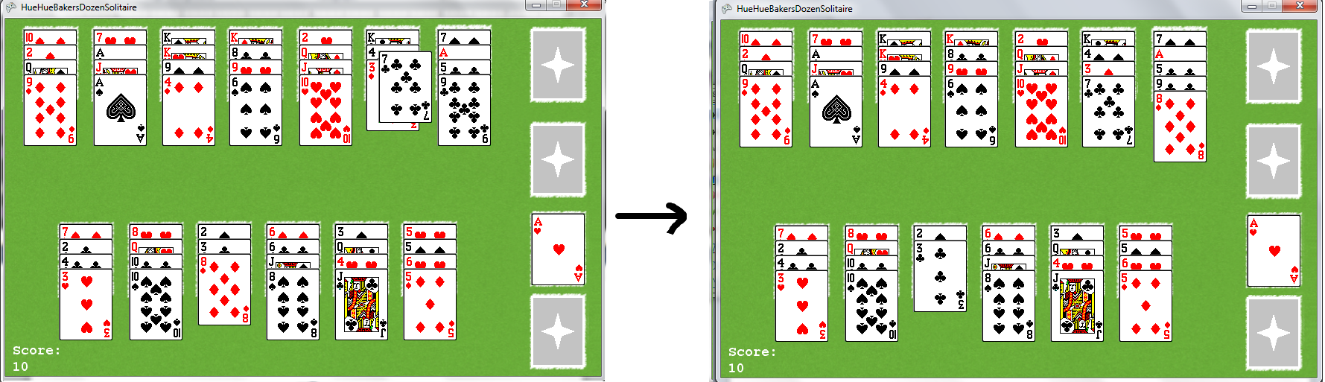

REQ-9.3: The system shall not allow a card to be placed in a pile where the current top card is any rank below the card being moved

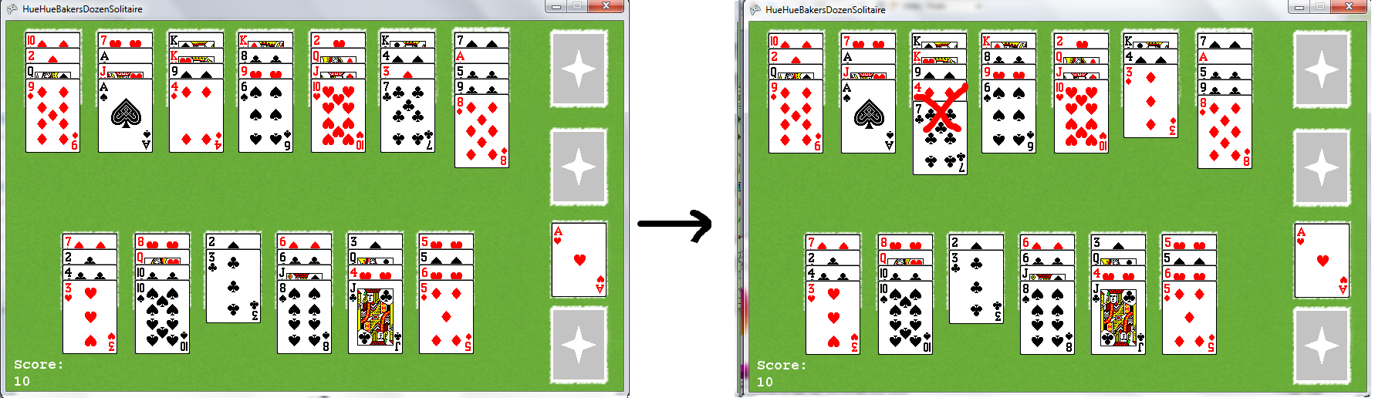

REQ-9.4: The system shall not allow a card to be placed in a pile where the current top card is of the same rank as the card being moved

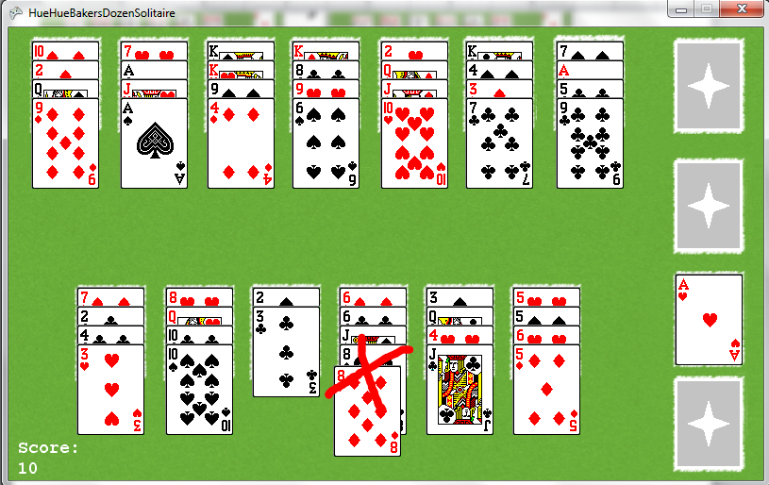

REQ-9.5: The system shall not allow a card to be placed in a pile where the current top card is +2 ranks or more above the card being moved.

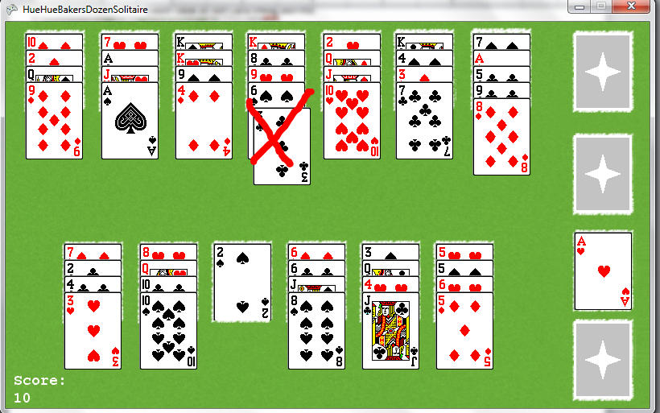

REQ-10: The system shall end the game when all cards are moved from the tableau to the foundation.

